**Name: Umme Habiba**

**Intern ID: TN/1N01/003**

**Email ID : saeedhabiba001@gmail.com**

**Internship Domain : Python Internee**

**Task Week : 5th**

**Instructor Name : Hassan**

**Task 1 :**

Write your Task Discription

**Solution :**

def square_numbers(numbers):

    squared = []

    for num in numbers:

        squared.append(num ** 2)

    return squared

#taking input from user

user_input = input("Enter numbers: ")

num_list = [int(x.strip()) for x in user_input.split(',')]

print("Squares:", square_numbers(num_list))

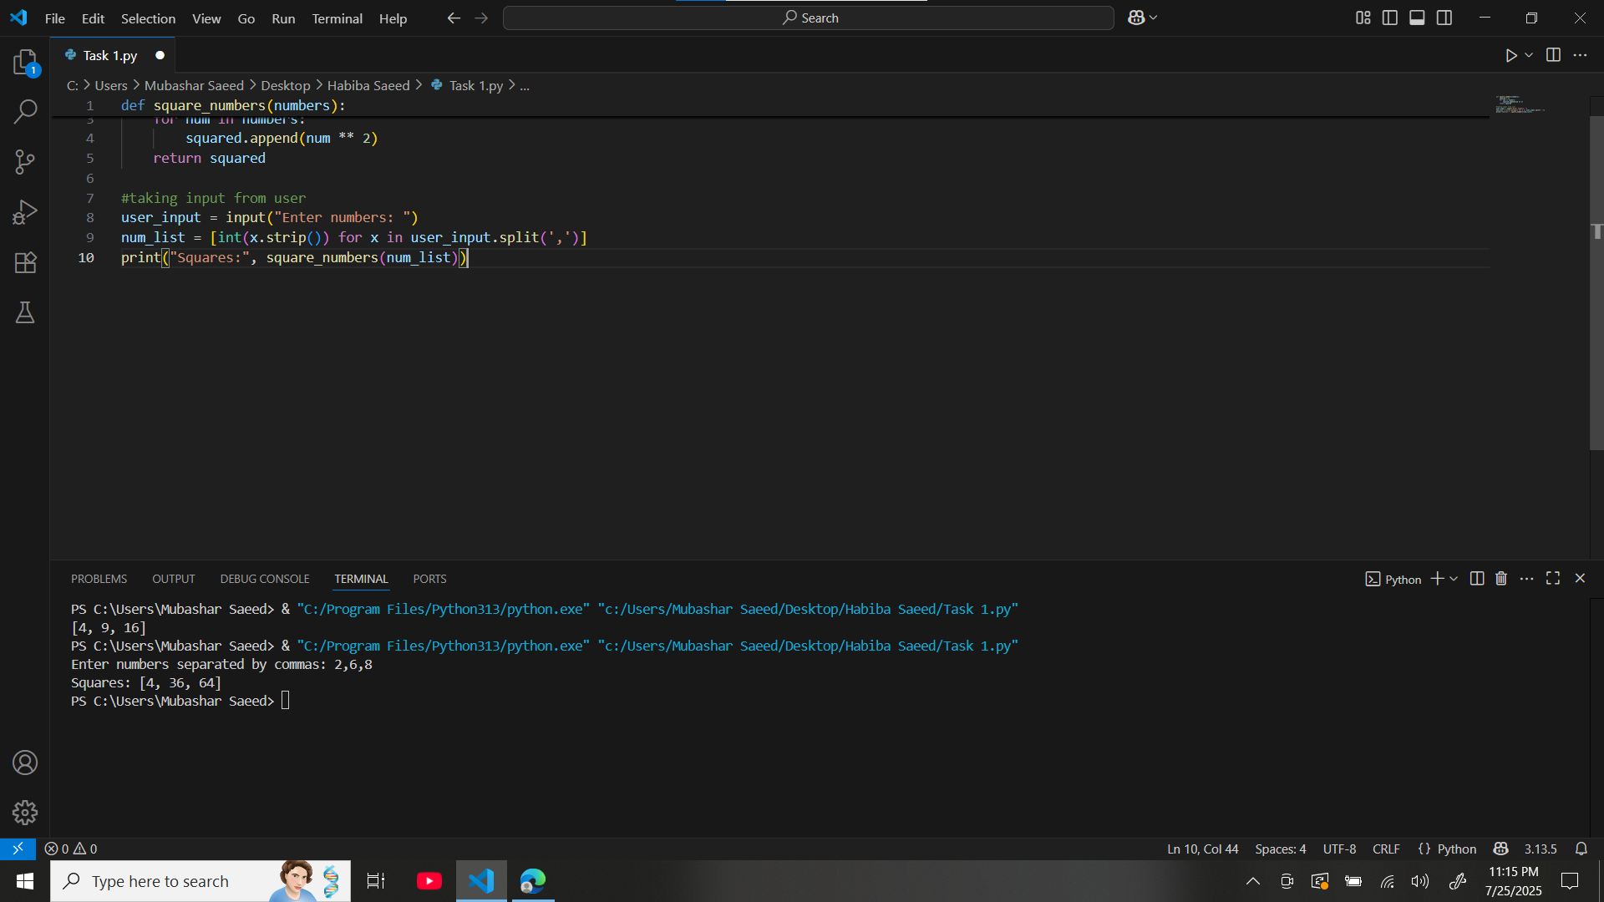

**Task 2 :**

**Solution :**

def is_even_or_odd(number):

    if number % 2 == 0:

        return "Even"

    else:

        return "Odd"

#taking input from user

num = int(input("Enter a number to check if it's even or odd: "))

print("The number is", is_even_or**_odd(num))**

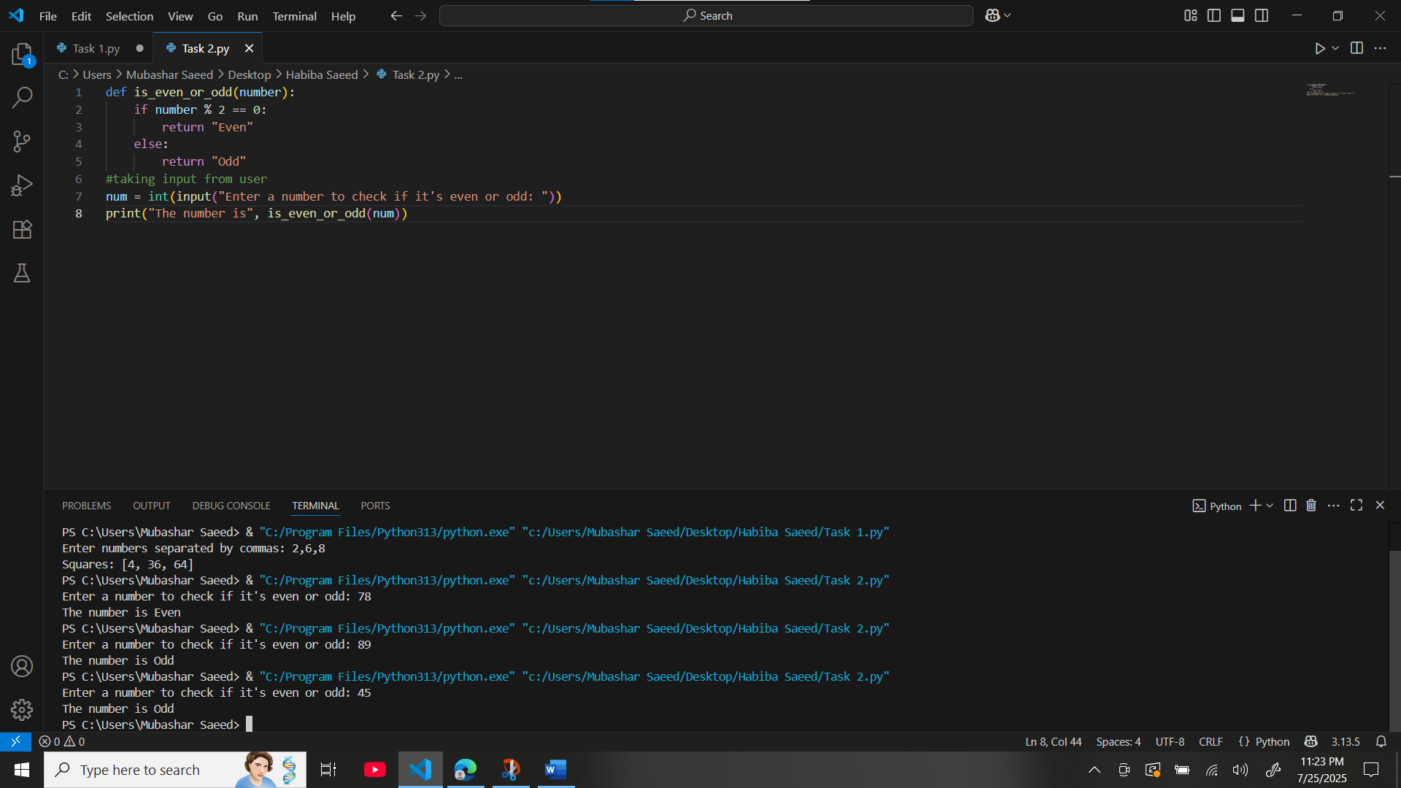

**Task 3 :**

**Solution :**

import math

def calculate_area(radius):

    return math.pi * radius * radius

#taking input from user

radius = float(input("Enter the radius of the circle: "))

print("Area of the circle is:", calculate_area(radius))

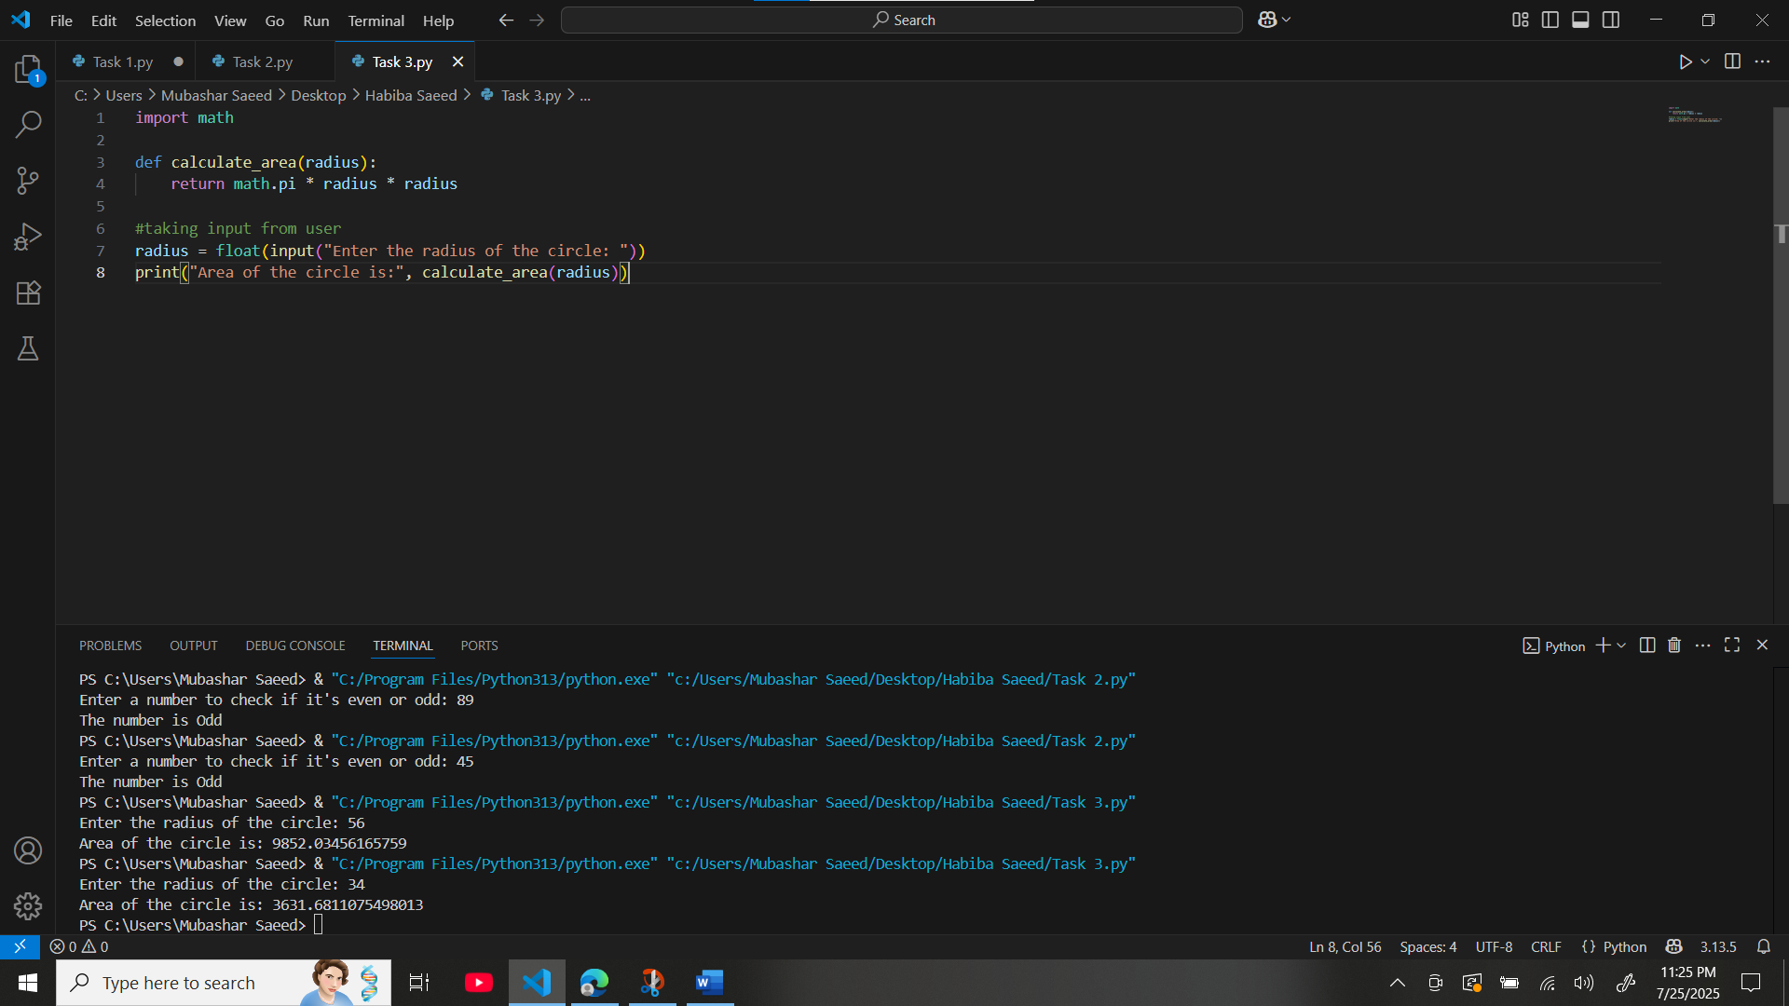

**Task 4 :**

**Solution :**

def greet_user(name, age):

    return f"Hello {name}, you are {age} years old."

#taking input from user

name = input("Enter your name: ")

age = input("Enter your age: ")

print(greet_user(name, age))

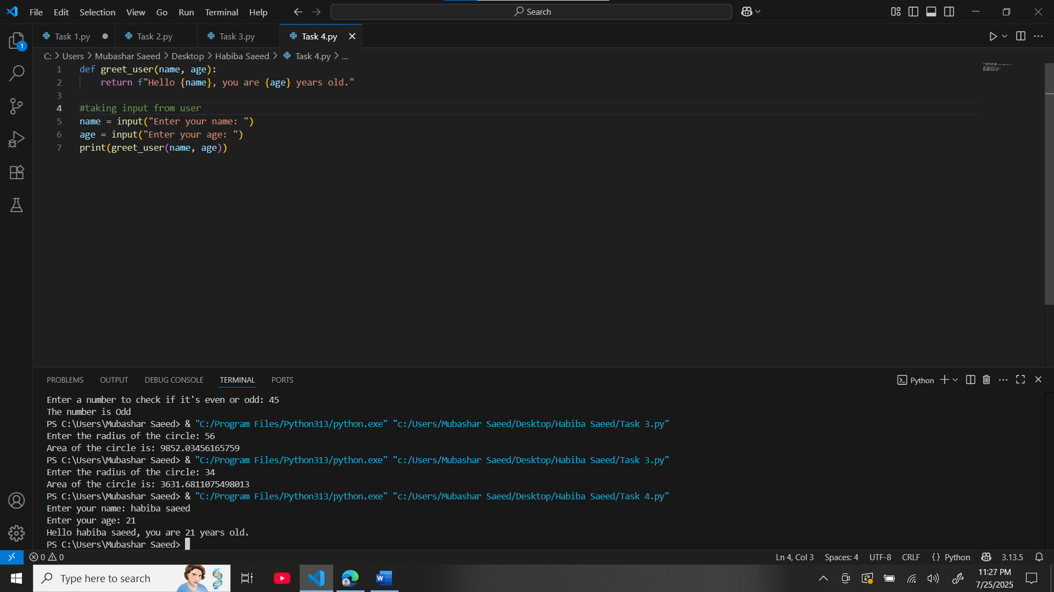

**Task 5 :**

**Solution :**

counter = 0  #global variable

def change_counter():

    global counter

    counter += 1

times = int(input("How many times do you want to update the counter? "))

for _ in range(times):

    change_counter()

print("Counter value is:", counter)

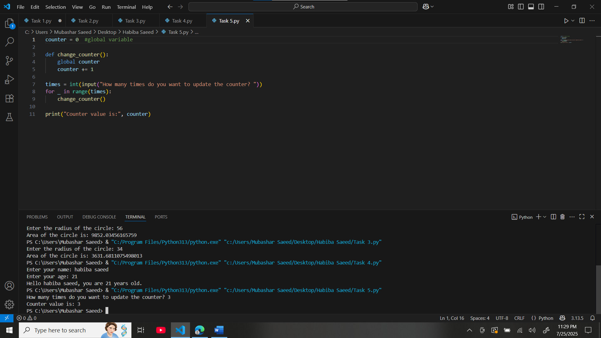

**Task 6 :**

**Solution :**

# main.py

from math_tools import multiply

x = int(input("Enter first number: "))

y = int(input("Enter second number: "))

print("Multiplication Result:", multiply(x, y))

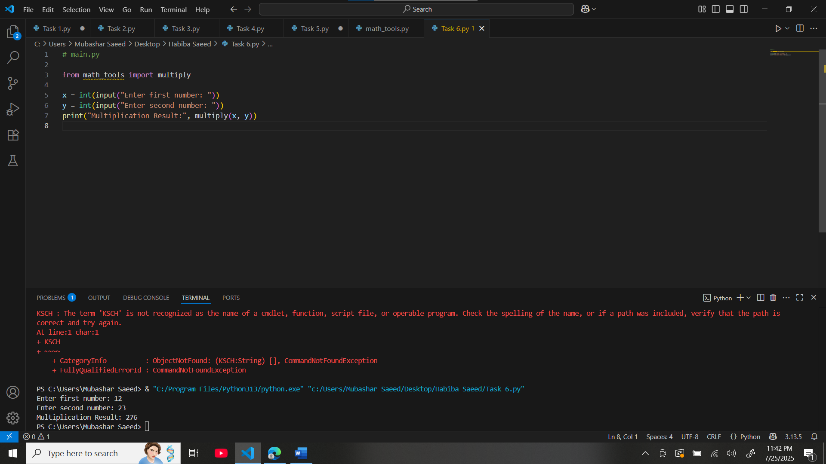

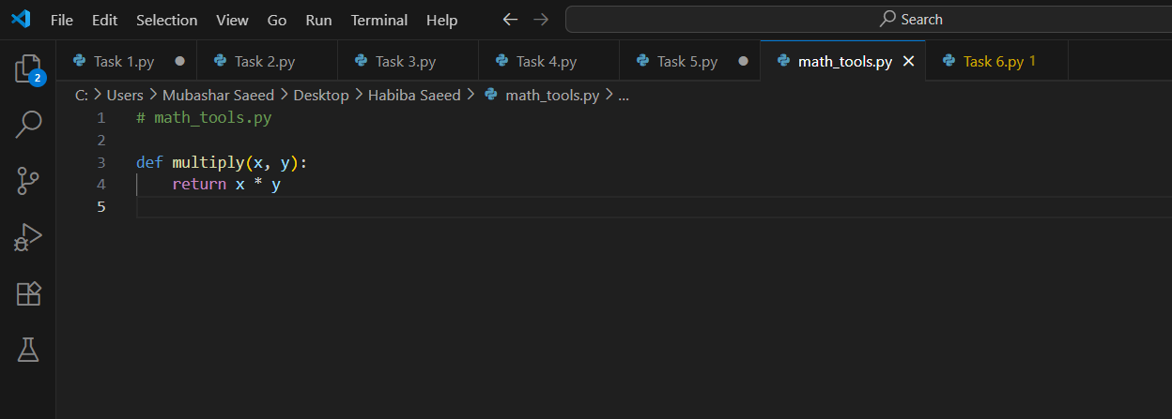

def multiply(x, y):

    return x * y